BlinkIT Grocery Sales Analysis — Project Report

Executive Summary

This project analyzes the BlinkIT grocery dataset to uncover insights related to sales performance, outlet characteristics, product categories, and customer preferences. The Power BI dashboard visualizes key business metrics such as Total Sales, Average Sales, Number of Items, and Average Rating, along with detailed breakdowns by Item Type, Fat Content, Outlet Size, Outlet Location, and Outlet Type.
The dashboard reveals that BlinkIT achieves $248.99K in total sales across 1,753 products with an average rating of 3.9. Most sales are driven by high-performing categories such as Snacks, Fruits & Vegetables, and Frozen Foods, while Tier 3 outlets show the strongest sales performance among locations.

Introduction

The purpose of this analysis is to provide a data-driven overview of BlinkIT’s grocery performance across retail outlets and product categories. Using the cleaned BlinkIT grocery dataset, the dashboard highlights:
- Sales distribution across item types
- Outlet-level performance
- Fat content influence
- Customer rating patterns
- Impact of outlet size and location on sales

These insights support operational optimization, merchandising decisions, and marketing strategies.

3. Dataset Overview

Although the dashboard summarizes results, the underlying dataset contains fields such as:

- Sales, Item Weight, Item Visibility
- Item Type, Item Fat Content
- Outlet Type, Outlet Location, Outlet Size
- Outlet Establishment Year, Ratings

With 1,753 items, the dataset provides a holistic view of BlinkIT’s product and outlet ecosystem.

4. Key Metrics from Dashboard

4.1 Total Sales
- $248.99K total sales generated from all products and outlets.
- Indicates strong revenue performance across major categories.

4.2 Average Sales
- $142 average sales per item.
- Variations appear across outlets and categories.

4.3 Number of Items
- 1,753 total items listed.
- Represents a diverse category portfolio.

4.4 Average Rating
- 3.9 average customer rating.
- Suggests good product quality and customer satisfaction.

5. Exploratory Data Insights

5.1 Sales by Fat Content

- Regular Fat and Low Fat both contribute significantly.
- Total combined contribution equals the full $248.99K sales.
- No strong dominance by one fat category — indicating balanced customer preference.

5.2 Sales by Item Type

The highest-performing categories are:
Item Type | Sales
Snacks | $42K
Fruits & Vegetables | $35K
Frozen Foods | $25K
Household | $21K
Dairy | $21K
Baking Goods | $20K
Canned Foods | $19K
- Snacks top the list, indicating impulse-buy behavior.
- Essential categories like fruits & vegetables rank high, showing consistent daily demand.

5.3 Fat Content by Outlet
- Across Tier 2 and Tier 3 outlets:
  - Regular Fat items show higher sales in Tier 3.
  - Low Fat items perform well in Tier 2 but less in Tier 3.

5.4 Outlet Establishment Trend

- Sales trend over outlet establishment years (2010–2020) shows a peak around 2014–2015 with $132K.
- Newer outlets (2019–2020) stabilize around $45K.
- Indicates that older outlets retain stronger customer bases.

5.5 Outlet Size

- Dashboard highlights High-size outlets only.
- High-size outlets account for 100% of the displayed sales, implying:
  - Larger stores perform better
  - More products and inventory
  - Higher customer footfall

5.6 Outlet Location Performance

Tier-wise total sales:
Tier | Sales
Tier 3 | 164.38K
Tier 2 | 84.61K
- Tier 3 contributes 66% of total sales.
- Indicates Tier 3 cities have higher demand or better outlet performance.

5.7 Outlet Type Performance

Outlet Type | Total Sales | No of Items | Avg Sales | Avg Rating | Item Visibility
Grocery Store | $32.57K | 233 | $140 | 4 | 0.11
Supermarket Type 1 | $216.42K | 1520 | $142 | 4 | 0.06
- Supermarket Type 1 accounts for nearly 87% of all sales, with significantly more items.
- Grocery stores contribute less but maintain similar ratings and average sales.

6. Business Insights

6.1 Category Insights

- Snacks and fresh produce are top-performing categories → focus on inventory expansion.
- Lower-performing categories like Seafood and Hard Drinks require targeted promotional strategies.

6.2 Location Insights

- Tier 3 outlets show higher overall sales → potential for expansion.
- Tier 2 may require:
  - improved promotions
  - better product mix
  - enhanced store layout

6.3 Outlet Type Insights

- Supermarket Type 1 is the key revenue driver.
- Grocery Stores contribute modestly → upgrade strategy or SKU optimization required.

6.4 Product Quality Insight

- Average rating of 3.9 indicates healthy customer satisfaction.
- Opportunity: Introduce premium SKU lines for higher-rated items.

7. Recommendations

- Increase inventory for top-selling categories (Snacks, Fruits & Vegetables).
- Introduce targeted promotions for low-performing categories.
- Develop marketing campaigns for Tier 2 cities.
- Optimize Grocery Store performance through assortment changes.
- Improve product visibility for low-visibility but high-potential items.
- Enhance loyalty programs to improve repeat purchases.

8. Conclusion

The dashboard provides a comprehensive view of BlinkIT’s grocery performance. High sales from key categories, strong Tier 3 performance, and positive customer ratings reflect a healthy business model. However, there is room for operational improvements in outlet types, category performance, and geographical strategies.
With deeper analysis and enhancement of predictive models, BlinkIT can optimize both product assortment and regional strategies to achieve higher profitability.

PROJECT:
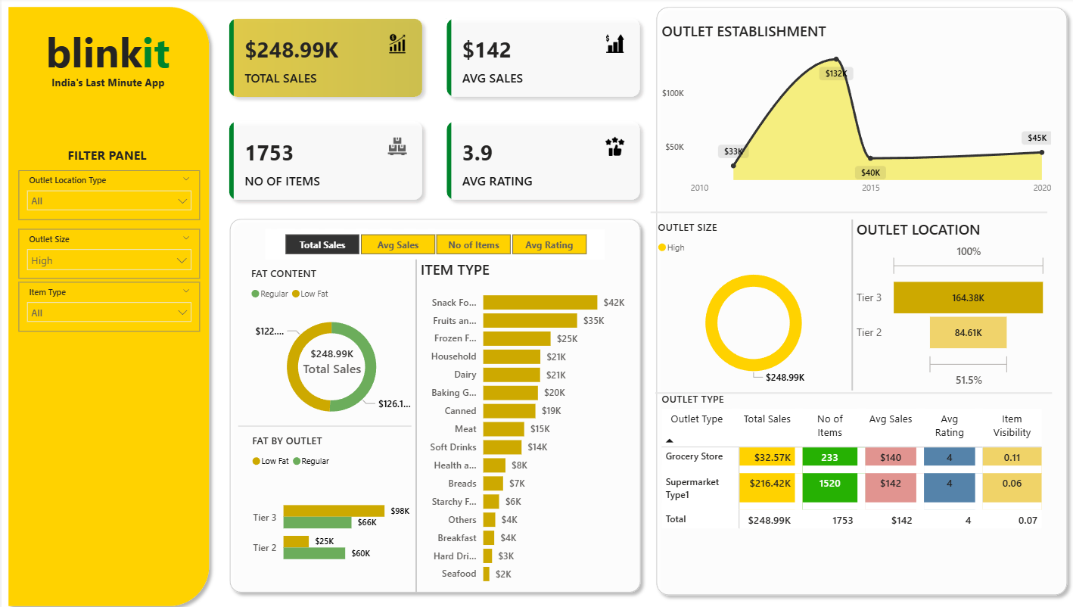

Thank You

--Aafiya K Tarade

